**AGENDA - Little Hoole Parish Council**

*Members of the Council are summoned to the Parish Council Meeting to be held on   
Mon 11th Nov 2024 at 7:00pm*

***The Lounge, Old Mill Court Retirement Housing, Liverpool Old Road, Walmer Bridge, PR4 5QU***Paul Cafferkey, Clerk & Responsible Financial Officer

1. Apologies for absence
2. To agree the Minutes of the last Parish Council Meeting
3. To receive declarations of interest
4. Matters arising from the minutes of last meeting
   1. Public Time: to invite and listen to issues raised by members of the public
   2. Donation Request from Hoole Bowling Club
   3. Planning Applications:
      1. 07/2024/00773/FUL. 67B Liverpool Old Road Walmer Bridge PR4 5QE. Alterations to shop front.
   4. To approve the following transactions in the bank for Oct 2024:

|  |  |  |  |
| --- | --- | --- | --- |
| Date | Payee | £ | Description |
| 01-Oct-24 | Direct Debit (GOCARDLESS) | 36.96 | Monthly website fee |
| 11-Oct-24 | B/P to: Adam Watson | 244.76 | Repair & Painting of Planters |
| 11-Oct-24 | B/P to: Mayor & Sons Ltd | 516.00 | Christmas Tree |
| 17-Oct-24 | B/P to: PKF Littlejohn LLP | 252.00 | External Audit Fee |
| 17-Oct-24 | B/P to: Paul Cafferkey | 3.20 | Clerk's Expenses Tax Mth 7 |
| 17-Oct-24 | B/P to: Paul Cafferkey | 181.60 | Clerk's Salary Tax Mth 7 |
| 18-Oct-24 | B/P to: Festive Lights | 51.94 | Christmas Lights |
| 24-Oct-24 | Direct Debit (HMRC SDDS) | 107.60 | Employee's Tax, Mths 5,6&7 |
| 31-Oct-24 | Service Charge | 5.40 | Bank Charges |

* 1. Payments for approval
     1. Clerk’s claim for Oct 2024
  2. To receive the Clerk’s Financial Statement report as at 31st Oct 2024
  3. To approve the Clerk’s pay award and backpay.
  4. To approve Clerk’s SLCC annual subscription.
  5. To approve Clerk’s Microsoft 365 annual subscription.
  6. To approve additional signatory to bank account.
  7. To discuss possible projects for 2025-26 budget.
  8. To discuss School Crossing Patrol re A59
  9. To consider request from Little Hoole Primary School for banners to be displayed on Parish Council Planters.
  10. To consider proposal for a Parish Council logo.
  11. Donation Request from Walmer Bridge Village Hall – outcome.
  12. To record a vote of thanks for the volunteers who put up Remembrance lamp post poppies.
  13. Information and Updates.
  14. Correspondence.
      1. Email from resident re allotments.
      2. SRBC Review of Polling Districts and Polling Reviews
      3. Response from LCC regarding a bus service link from Little Hoole and surrounding areas, to serve Leyland and Chorley.
  15. To agree the date, time, and venue for the Dec 2024 meeting.

**Members of the public are welcome to attend meetings to raise any relevant matters. Alternatively, if you cannot attend the meeting but wish to raise a matter or ask a question, this can be done on your behalf by contacting the Parish Clerk (Paul Cafferkey) via email at** [**clerk@littlehooleparishcouncil.org.uk**](mailto:clerk@littlehooleparishcouncil.org.uk) **or mobile phone 07966267186.**

Scan me to go the Little Hoole Parish Council Website, or visit <https://www.littlehooleparishcouncil.org.uk/>

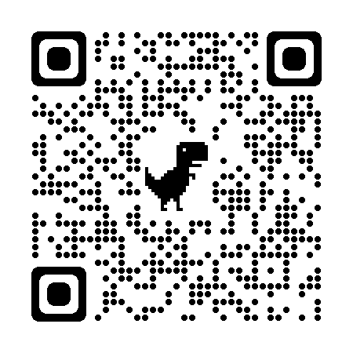

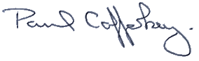Prepared and approved by Paul Cafferkey, Clerk – Little Hoole Parish Council,   
6th Nov 2024